**VPM's K.G. Joshi College of Arts and N.G. Bedekar College of Commerce        (Autonomous), Thane**

**Activity Report**

**1. Name of the Activity: Community Engagement Program (CEP)**

**2. Name of the Department: Sanskrit with All Humanities Departments  of Joshi Bedekar College**

**3. Day & Date: 11 February 2025,Tuesday**

**4.Venue: Thorale Bajirao Peshave Sabhagriha**

**5. Resource Person: Dr. Vijay Bedekar , Mrs.Sumedha Bedekar and Shri.Rajendra Salve**

**6. Number of Participants: 30**

**7. Purpose of the Activity: Purpose of the Activity: Community Engagement Program – "या जन्मावर शतदा प्रेम करावे" The purpose of organizing the Community Engagement Program (CEP) titled "या जन्मावर शतदा प्रेम करावे" is to promote empathy, respect, and emotional connection with the elderly members of society. This initiative encourages students to engage meaningfully with senior citizens and understand their experiences, challenges, and wisdom, thereby nurturing intergenerational bonding and a sense of social responsibility.**

**The key objectives include:**

1. **Promoting Compassion and Respect for the Elderly  
    To help students understand the emotional and social needs of the elderly and cultivate a respectful and caring attitude towards them.**
2. **Bridging the Generation Gap  
    By interacting with older adults, students gain valuable insights and life lessons, which helps build a mutual understanding between generations.**
3. **Creating a Sense of Belonging for the Elderly  
    The program aims to reduce feelings of loneliness and isolation among senior citizens by making them feel heard, valued, and appreciated.**
4. **Encouraging Community Service and Responsibility  
    To instill a sense of civic duty in students, encouraging them to contribute positively to society through compassionate action and volunteerism.**
5. **Celebrating Life and Experience  
    The title "या जन्मावर शतदा प्रेम करावे" reflects the beauty of life and encourages both students and the elderly to celebrate life’s journey with gratitude and joy.**
6. **Promoting Mental and Emotional Well-being  
    Such engagement provides emotional support to the elderly and creates a positive environment that boosts their morale and well-being.**

**8.Gist of the Activity:**

**a. With the guidance of NEP Cell department of Sanskrit with All Humanities of Joshi Bedekar College organized a Community Engagement Program on Tuesday, 11th February 2025 in Thorale Bajirao Peshave Sabhagriha. Resource Person Dr. Vijay Bedekar , Mrs.Sumedha Bedekar and Shri.Rajendra Salve guided us.The Community Engagement Program (CEP) for Elderly People is designed to foster social inclusion, well-being, and active participation among senior citizens. Through interactive sessions, recreational activities, and intergenerational exchanges, the program provides a supportive environment where elders can share experiences, learn new skills, and stay mentally and physically engaged. It aims to reduce isolation, promote lifelong learning, and recognize the valuable contributions of the elderly to society  This Community Engagement Program aims to foster empathy, respect, and meaningful interaction with elderly people through student participation. By spending quality time, sharing stories, and organizing cultural or interactive sessions, the program helps bridge the generation gap and promotes emotional well-being among senior citizens. It encourages students to value life experiences, build compassion, and contribute positively to society, truly reflecting the spirit of "falling in love with life a hundred times."**

**.  We are thankful to Principal Dr. Suchitra A Naik Madam for her continuous support and guidance,The session ended with a vote of thanks.**

**8. Teacher Incharge :-  Asst. Prof. Swati Bhalerao / Asst. Prof. Rohini Joshi and All Humanities Departments  of Joshi Bedekar College**

**Thanks and Regards**

**Asst. Prof. Swati M. Bhalerao  Dr. Suchitra A. Naik**

**HoD Sanskrit Principal**

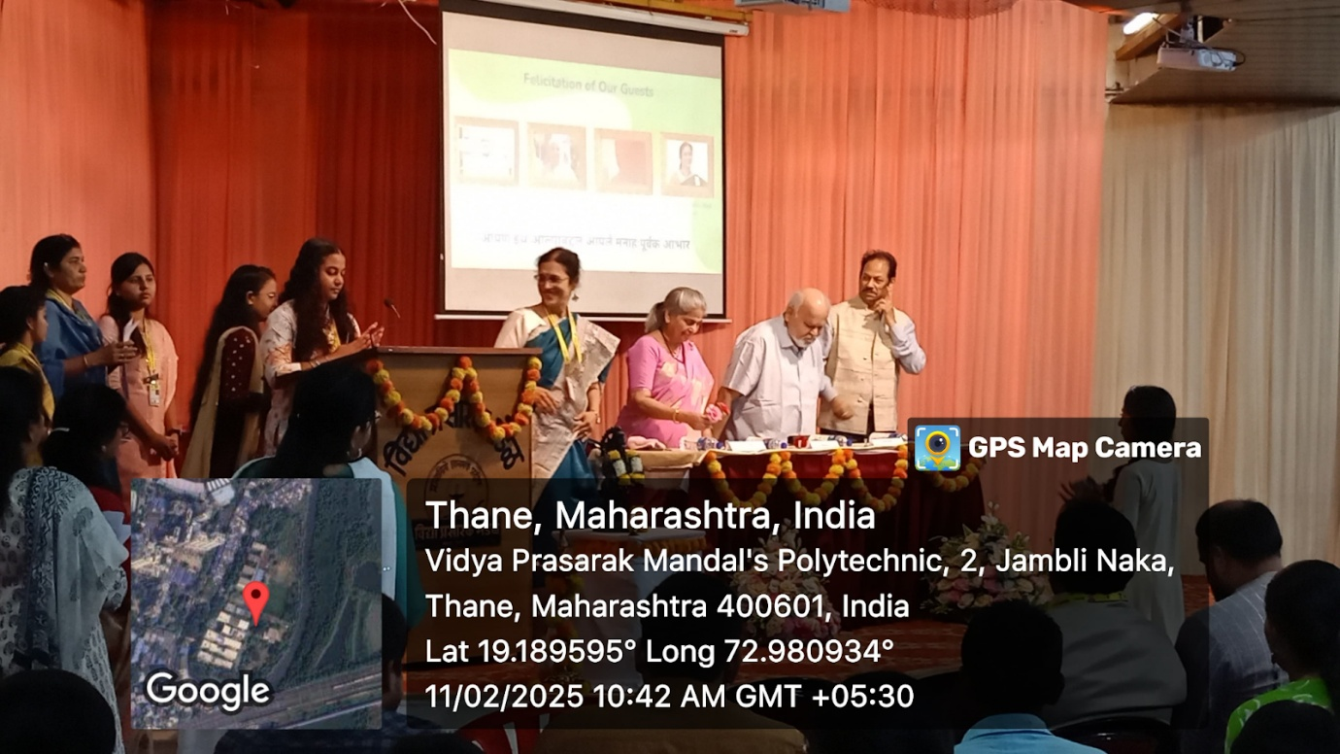

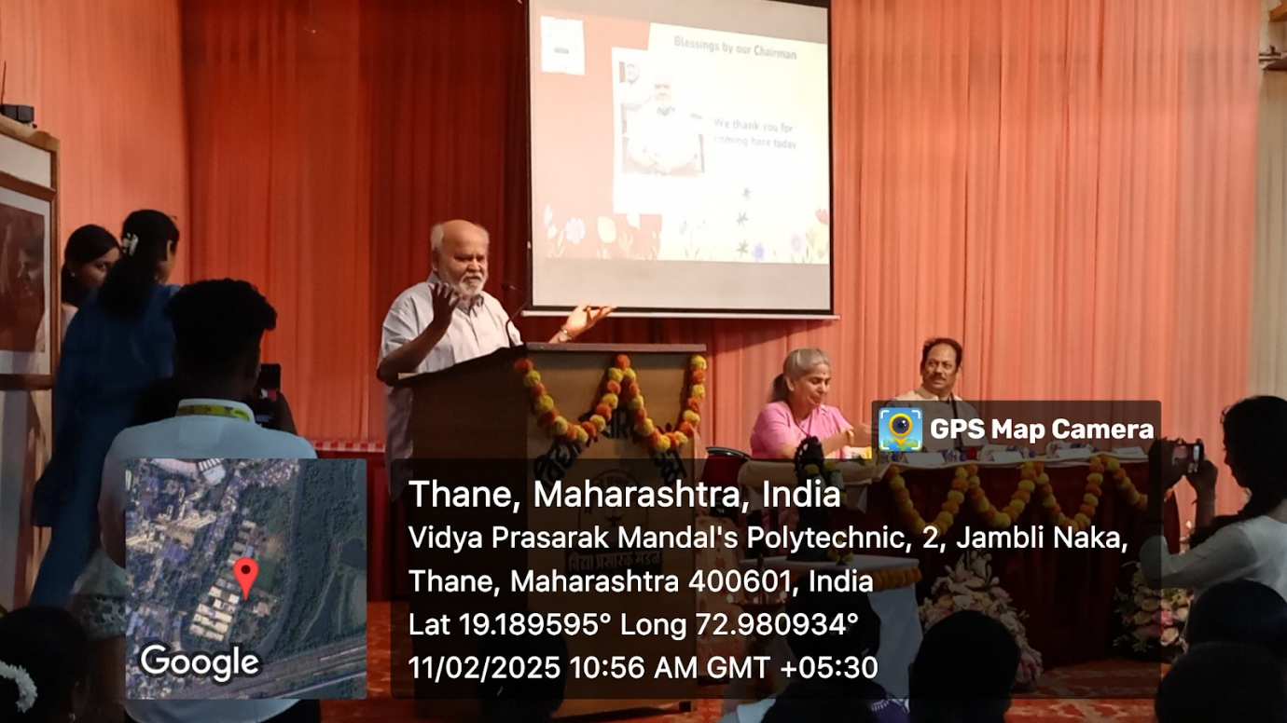

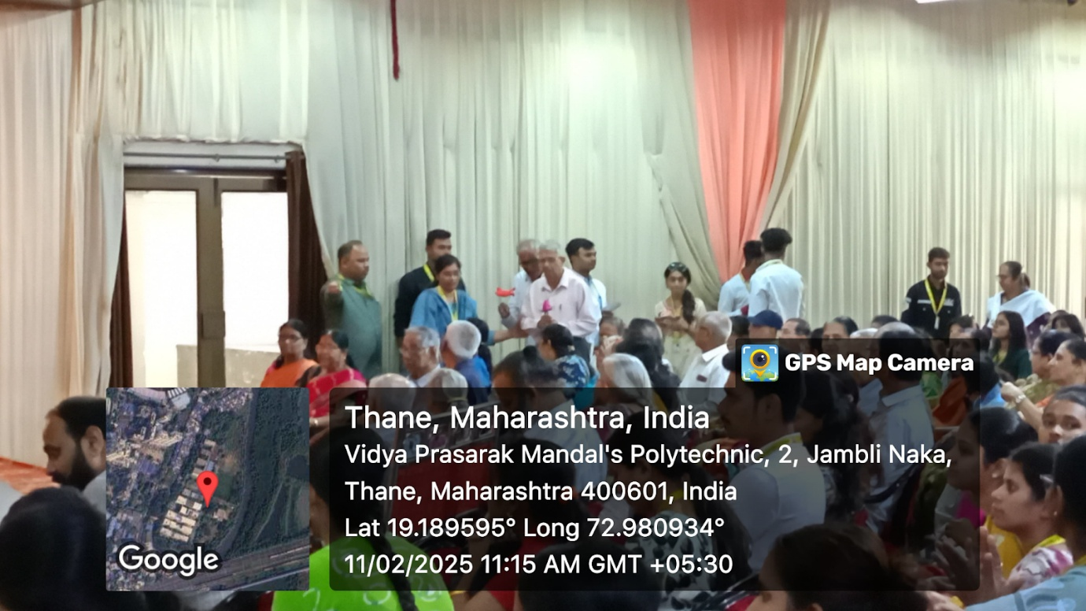

**Community Engagement Program (CEP)11 February 2025,Tuesday**